

PROPOSAL DOCUMENT

SUPPORT SERVICES SLA

© Sautech (Pty) Ltd. http://www.sautech.net

TABLE OF CONTENTS

1 Purpose and Objectives 4
1.1 Parties to the agreement 4
1.2 Commencement Date 4
1.3 Annual anniversary 4
1.4 Duration of Agreement 4
1.5 Non-exclusive agreement 4
2 Interpretation Definitions 5
2.1 Definitions 5
2.2 Interpretation 6
3 BAckground of services 7
3.1 Place of Service delivery 7
3.2 Changes to Services 7
3.3 Cost Analysis 7
4 PERFORMANCE, TRACKING AND REPORTING 8
4.1 Key Personnel Changes 8
4.2 How each service will be monitored 8
4.3 Benchmarks, targets and metrics to be utilised 8
5 Service LeveLS 8
6 Support and Service desk Services 9
7 COMPENSATION 9
7.1 Fees 9
7.2 Adjustment to Fees 9
7.3 Reimbursable expenses 9
7.4 Invoices 9
7.5 Payment terms 9
7.6 VAT 10
7.7 Interest for late payment 10
8 CUSTOMER DUTIES AND RESPONSIBILITIES 10
8.1 Processing and authorisation of invoices 10
8.2 Client personnel, facilities and resources 10
8.3 Approvals and Information 10
9 WARRANTIES AND REMEDIES 10
9.1 Quality of Service 10
9.2 Indemnification 10
9.3 Third party claims 11
9.4 3rd Party Vendor Contracts 11
9.5 Software and application licensing 11
9.6 Exclusions 11
9.7 Defaulting Performances 12
9.8 Force Majeure 12
10 security 12
10.1 Physical Access 12
10.2 Logical Access 12
10.3 Compliance with Client Security Policies 12
10.4 Information and data security measures 14
10.5 Securities 14
10.6 Disaster recovery 15
10.7 Encryption 16
11 INTELLECTUAL PROPERTY RIGHTS AND 16
CONFIDENTIAL INFORMATION 16
11.1 Intellectual property rights 16
12 Confidentiality 17
12.1 Court orders 17
12.2 Destruction of data and records or return on termination 17
12.3 System Confidentiality – Shared Environment 17
13 Dispute resolution 18
13.1 Informal 18
13.2 Arbitration 18
14 Limitation of liability 19
15 Duration &termination 19
15.1 Payment on termination 19
16 general 20
16.1 Relationship 20
16.2 Notices 20
16.3 Standard of care 20
16.4 Assignment 21
16.5 Entire Agreement 21
16.6 Severability 21
16.7 Changes to the Agreement 21
16.8 Non-solicitation 21
16.9 Exhibits 21
16.10 Governing Law 21
17 signatures 22
18 Schedules 23
18.1 SCHEDULE A – STANDARD SERVICES 23
18.2 Server Management 23
18.3 SCHEDULE C – SERVICE AVAILABILITY 25
18.4 SCHEDULE D – PLACE OF DELIVERY 26
18.5 SCHEDULE E – CHANGE CONTROL PROCEDURES 27
18.6 SCHEDULE F – SERVICE MONITORING AND PERFORMANCE MEASUREMENT 28
18.7 SCHEDULE G – SERVICE LEVEL REPORTING 30
18.8 SCHEDULE H – SUPPORT & SERVICE DESK SERVICES 31
18.9 SCHEDULE J – FEES AND EXPENSES 32
18.10 SCHEDULE L – NOTICES 33
Physical Address 33
Physical Address 33
18.11 SCHEDULE M – CHANGES TO AGREEMENT 34

Purpose and Objectives

This Agreement outlines the terms and conditions under which the Supplier will provide specified Services (collectively referred to as “the Services”) to its Client or its Affiliates. The objective is to provide a basis and framework for the delivery of high quality services that meet the needs of the Client. This Agreement with become the Services and Hosting Agreement (Master Services Agreement) upon acceptance.

Parties to the agreement

This Agreement is made between Sautech (Pty) Ltd – Registration number: 2003/006814/07 (hereinafter referred to as “the Supplier”) and ANVIL MINING CONGO SA, Identification National : 01-118-N37015X - RCCM No : CD/L’SHI/RCCM14-B 1690 - Tax Number :A0700172W (hereinafter referred to as “the Client”)

Commencement Date

This Agreement will commence on 22 July 2017

Annual anniversary

This annual anniversary is 28 February of each calendar year following the next business year of this agreement. On this date, the fee structures in this agreement will be incremented with a standard rate related to the annual released CPIX rate if applicable to the specific service or services. Before this takes effect, all services will be discussed and agreed upon in writing between the Supplier and the Clent.

Duration of Agreement

This Agreement is on a month to month contract basis after signoff and implementation and is automatically renewable for a further month at the end of this initial period and on each subsequent anniversary of the Commencement Date unless 60 days prior written notice is received to terminate the Agreement by either party.

Non-exclusive agreement

It is understood and agreed that this Agreement does not grant to the Supplier any exclusive rights to do business with the Client and also that the Client may contract with other suppliers for the procurement of similar services. Nothing in the Agreement prevents the Supplier from marketing, developing, using and performing similar services or products to other potential clients.

Interpretation Definitions

Definitions

“Affiliate” means a subsidiary organisation, sister organisation or an organisationally connected entity to either party.

“Benchmarks, targets and metrics” means the agreed numeric criteria against which performance under this Agreement is to be measured.

“Change control procedures” means the agreed process to be followed when changes are required either to this Agreement or to the Services and as set out under Schedule E

“Commencement date” means the date that the Agreement is considered to be effective.

“Defective or inadequate performance” means the delivery of services where the performance levels do not meet an agreed minimum criteria.

“Disclosing party” means the party who has disclosed confidential information to the other party.

“Initial period” means the Agreement period from the Commencement date to the first renewal date.

“Intellectual property rights” mean the registered or non-registered ownership of patents, trademarks, registered design, know-how or copyright.

“Key personnel” mean those persons employed by the Supplier who have a key role in the delivery of the services to the Client.

“Non-standard services” means those services which are customised to meet the requirements of the Client.

“Place of service delivery” means the address or addresses of the Client’s or Supplier’s premises where the Service delivery is deemed to take place.

"Prime Rate" means the interest rate, (expressed as a percentage per annum) from time to time, published by ABSA Bank Limited as the minimum overdraft rate at which it lends to its most valued customers in the corporate sector, as certified by any manager of such bank, whose appointment or authority it shall not be necessary to prove, which certificate shall, in the absence of manifest error, be prima facie proof of the contents thereof;

“Problem escalation” means the agreed procedure for alerting and notifying increasingly senior members of the Supplier’s management of the non-resolution of problems.

“Problem management” means the agreed procedures for providing support and problem resolution services to the Client.

“Professional fees” means the remuneration or compensation, other than reimbursable expenses, due to the supplier for the provision of the Services.

“Receiving party” means the party who has received confidential information from the other party.

“Service availability” means the times and periods that the Supplier will make the Services available to the Client.

“Service component” means a divisible and identifiable part of the overall Services to be delivered.

“Service review meetings” mean regular meetings that are held between representatives of the Supplier and the Client specifically to discuss issues arising from the delivery of the Services including the performance of the Service delivery

“Specified services” means those Services that are specified in Schedule A and Schedule B of this Agreement.

“Standard services” mean those Services that the Supplier delivers to its Clients without significant customisation.

“Support and Service desk services” mean the specified support services provided by the Supplier to the Client to assist the Client’s personnel to understand operate and execute the delivered Services.

“Business Days” - Business days has been defined as Monday to Friday, 8am to 5pm, excluding public holidays.

“Value Added Tax” - All quoted prices exclude 14% Vat

“Payment Terms” – “See 9.5”

“The Client Staff and Resources costs”– All costs associated with The Client or The Client’s representatives, have not been included in this proposal

“Rates” – Should the project cost overrun in any way, The Supplier will first discuss terms with The Client and approval needs to be given on an Amendment agreement to the original.

Interpretation

- The Clause headings in this agreement have been inserted for convenience only and will not be taken into consideration in its interpretation.
- Expressions defined in this Agreement shall bear the same meanings in schedules or annexures to this Agreement which do not themselves contain their own conflicting definitions;
- The expiration or termination of this Agreement shall not affect such of the provisions of this Agreement as expressly provide that they will operate after any such expiration or termination or which of necessity must continue to have effect after such expiration or termination, notwithstanding that the clauses themselves do not expressly provide for this;
- A person includes juristic legal persons and vice versa
- A gender includes reference to the other.

BAckground of services

The Supplier is contracted to perform maintenance, support, monitoring and infrastructure support request services to the infrastructure hosted within the Afrihost Datacentre.

Place of Service delivery

The Services covered by this Agreement are to be delivered at the address or addresses given in Schedule D to this Agreement.

Changes to Services

Either party may propose changes to the scope, nature or time schedule of the Services being performed under this Agreement. The parties will mutually agree to any proposed changes, including adjustments to fees and expenses as a result of any changes to the Services. All changes are to be subject to the Change control procedures included in Schedule E to this Agreement and must be approved in writing by both parties.

Cost Analysis
The Infrastructure, setup costs, monthly remuneration and all other services defined throughout this agreement is set out in Schedule N to this agreement.

PERFORMANCE, TRACKING AND REPORTING

Key Personnel Changes

Key personnel are not required to be specifically named within this Agreement but the Supplier will notify the Client in advance of changes to any key personnel that could affect the delivery of the Services to the Client.

How each service will be monitored

The performance of each individual Service will be monitored. The methodology to be used in each case is outlined in Schedule F to this Agreement.

Benchmarks, targets and metrics to be utilised

The benchmarks, targets and metrics to be used in the measurement of performance levels are defined in Schedule F to this Agreement.

Service LeveLS

The Supplier shall render the Services in accordance with agreed Service levels and monitor the Service levels as set out under Schedule G

- Reports on actual service levels achieved will be provided to the Client upon request
- The Parties may, from time to time, add to or vary the Service Levels in accordance with the Contract Change Management Procedure (see Schedule H).
- The Parties may, from time to time, add to or vary the Service Levels in accordance with the Contract Change Management Procedure (see Schedule H).
- Both Parties shall on an on-going basis, pro-actively seek opportunities (“Opportunities”):
  - to achieve greater efficiencies in the provision of the Services; and/or
  - for the Client to achieve improvements in its business through the innovative use of information technology; and/or
  - To propose other innovative uses of information technology or innovative changes and/or improvements in the provision of the Services.
- To this end, the Supplier shall, when Opportunities arise, propose to the Client, on a case-by-case basis, the possible implementation of proposed business initiatives that would result in achieving greater efficiency and effectiveness in the use of information technology by the Client, and other consequential business benefits. Such the Supplier’s proposals will be prepared at the Supplier’s expense and shall address the manner of implementation of the proposed initiatives, the timing thereof and the impact on the Services Charges, if any and the manner or extent to which both Parties will share in the benefits derived from the efficiencies gained.

The Client is under no obligation to accept any such proposals. If the Client accepts a proposal in writing, the Parties shall implement it

Support and Service desk Services
The Supplier will provide on-going assistance to the Client to support the Services provided. This will include comprehensive Service desk facilities and Hosting Services. The Service desk and hosting services are defined in Schedule H to this Agreement

COMPENSATION

Fees

The Fees payable for performing either the Standard Services or the Non-standard Services are to be in accordance with the basis as defined in Schedule J to this Agreement.

Adjustment to Fees
The Service Fees shall be adjusted annually on the anniversary of the Commencement Date in the manner as provided for in Schedule J and if applicable; and will, if applicable, be adjusted with any Service Level Credits calculated and agreed in accordance with Schedule K.

Reimbursable expenses
Reimbursable expenses mean agreed incidental services reasonably incurred by the Supplier in performing its obligations, plus a 10% administrative fee. Expenses that may be considered as reimbursable are stated in Schedule J to this Agreement. No expenses shall be incurred without the prior written approval of the Client.

Invoices
The Supplier will submit invoices to the client for professional fees in advance and agreed reimbursable expenses in arrears on a monthly basis. Each invoice will clearly state the work performed, hours worked and reimbursable expenses incurred.

Payment terms

All fees and expenses are to be paid to the Supplier, in South-African Rand, by Internet transfer of funds to the account designated by the Supplier. All invoices are payable within 30(thirty) days from the receipt of the invoice. Any amounts disputed in good faith may be deducted from the invoice and the remainder must be paid by the due date. The disputed amount should be notified in writing to the Supplier within 7(seven) days of receipt of the invoice giving the reasons for withholding payment. Upon receipt of the Client’s dispute notice, the Supplier and Client will work together in good faith to resolve such disputes in a prompt and mutually acceptable manner. The Client agrees to pay any disputed amounts within 5(five) days once the issues have been resolved.

VAT

The Supplier is registered for Value Added Tax and must add VAT as set out by the South African Revenue Services to all amounts quoted within and outside of this Agreement and is payable by The Client. All amounts or quotations arising from or outside this Agreement exclude the VAT unless clearly specified.

Interest for late payment

Any undisputed amount due by either Party whether in terms of this clause or any other clause of the Agreement, which is not paid on due date shall attract interest at Prime Rate percentage points, calculated 15 (fifteen) days after the specified due date of such undisputed amount until the date of payment, both days inclusive, compounded monthly.

CUSTOMER DUTIES AND RESPONSIBILITIES

Processing and authorisation of invoices

The Client undertakes to process and settle invoices by the due dates.

Client personnel, facilities and resources

The Client will ensure the Supplier has timely access to appropriate Client personnel and will arrange for the Supplier personnel to have suitable and safe access to the Client’s facilities and systems.

Approvals and Information

The Client will respond promptly, and in any case, within five working days, to any Supplier requests to provide direction, information, approvals, authorisations or decisions that are reasonably necessary for the Supplier to perform the services.

WARRANTIES AND REMEDIES

Quality of Service
The Supplier warrants that the Services will be performed in a professional and workmanlike manner consistent with industry standards reasonably applicable to such services. If the Client considers that a breach of this warranty has occurred and notifies the Supplier in writing stating the nature of the breach, then the Supplier will be required to urgently correct any affected services in order that they comply with the warranty.

Indemnification

If, as a result of the Supplier’s negligence, the Client or Client’s employees suffer injury or property damage, the Supplier will reimburse the Client for that portion of any damages for which the Supplier is found to be liable.

Third party claims

The Supplier warrants that any works of authorship written by the Supplier’s personnel will not infringe any third party copyrights, patents or trade secrets. If a third party takes action against the Client for any infringements of this nature, then the Supplier will, at its own expense, settle the claim or arrange to defend the Client in such proceedings, and, in such circumstances, the Supplier will pay all settlement costs, damages, and legal fees and expenses finally so awarded.

3rd Party Vendor Contracts
Any Contract, External Vendors, Software or hardware purchased from the Client during the contract duration, the Supplier will not be held liable for the support required on the specific product. The Supplier will however liaise and cooperate in its respective support capacity with the supplier to rectify and resolve the issues within a reasonable time.

Software and application licensing

Licensing

The Client is responsible for ensuring that all software used by its staff or affiliates and or contractors are fully licensed under its respective agreements. The Supplier will not take responsibility for unlicensed products and will configure and support the software only on behalf of The Client.
The Supplier will report the discrepancies, surpluses and shortfall of licenses in writing to The Client. The Client agrees to rectify the licensing as soon as reasonably possible.

The Hosting centre licensing
The software that the Supplier uses in the rendering of the Services or that it makes available to the Client for use in the rendering of the Services, is duly and properly licensed for the use and the extent of the use thereof, is currently under software maintenance and will be kept under software maintenance for the duration of the use thereof. The Supplier further warrants that it has obtained the written approval of the relevant software vendor/s:

- For the use, management and maintenance of such software by itself, on its own equipment and at its own premises or on the equipment of the Client and its premises;
- The Supplier shall forthwith and at the request of the Client, make such written approval available to the Client.

The Supplier has authorization from Microsoft to act on its behalf as a Microsoft Service Provider in terms of Licensing its hosted application for the purpose of the Suppliers’ business and then renting these licenses to his Clients.

Exclusions

Neither Party is responsible for any infringements to third party copyrights, patents or trade secrets where the other Party has made amendments to original documents and similar works prepared without the express approval of the relevant Party, or where the other Party fails to use the most recent versions of such works that have been delivered by a Party.

Defaulting Performances

In the event of any defective performance from the Supplier or failure to furnish the agreed level of service, the Supplier will make reasonable efforts to restore the service to a good operating condition on an urgent basis. If any penalties and refunds are payable in the event of defective service, the amounts claimable are as defined in Schedule K to this Agreement and shall be reflected against the Supplier’s invoice issued to the Clien

Force Majeure

- Except for disaster recovery services as per Schedule A, neither Party shall have any claim against the other Party ("the Affected Party") for any delay or failure of the Affected Party to carry out any of its obligations under this Agreement (except for a payment obligation in respect of Services already delivered but specifically excluding Services to be paid in advance) arising from or attributable to acts of God, war, terrorism, government, labour action or unrest, failure of suppliers or contractors or any other cause whatsoever beyond the control of the Affected Party ("force majeure").
- The performance of the obligations of the Affected Party shall, be suspended for the duration of the force majeure, which shall be deemed to commence only upon the date of written notice by the Affected Party to the other Party. A Party subject to force majeure shall take all steps that may reasonably be required to mitigate the effects thereof or to bring it to an end. Upon cessation of the force majeure, this Agreement shall again become fully operative and the Affected Party shall immediately resume its performance.
- If the suspension of performance continues for more than thirty (30) consecutive calendar days, then either Party may summarily terminate this Agreement by written notice to the other Party, prior to the cessation of the force majeure.

security

Physical Access

The Client is to ensure that the Supplier’s employees and sub-contractors are given reasonable authorised access to premises and equipment in order that the Services may be delivered and maintained in accordance with the terms of this Agreement.

Logical Access

The Client is to ensure that the Supplier’s employees and sub-contractors are given necessary access to the software and systems in order that the Services may be delivered and maintained in accordance with the terms of this Agreement.

Compliance with Client Security Policies

In the event that the Client operates formal security policies, the Supplier will ensure that its employees are made aware of such policies and will also ensure on-going compliance with these policy statements. The Client will provide the Supplier with up to date information on its security policies and will keep the Supplier informed about any changes to these policies. Where no policies are in place the Supplier shall ensure that its employees and representatives act in accordance with international standards in terms of security and access to the Client’s premises or systems.

Information and data security measures

The Supplier has a 3-Tier Network Security System in place for hosting Primary Data

Checkpoint Firewalls
- Top 100 of Fortune 100 utilizes checkpoint firewall security
- www.checkpoint.com for Gartner and other reports (Leader, 4 years in a row)
- CheckPoint VPN Clients (IPSEC)
Check Point Software Technologies Ltd. (www.checkpoint.com), the worldwide leader in securing the Internet, provides customers with uncompromised protection against all types of threats, reduces security complexity and lowers total cost of ownership. Check Point first pioneered the industry with FireWall-1 and its patented stateful inspection technology.
Today, Check Point continues to develop new innovations based on the Software Blade Architecture, providing customers with flexible and simple solutions that can be fully customized to meet the exact security needs of any organization. Check Point is the only vendor to go beyond technology and define security as a business process. Check Point 3D Security uniquely combines policy, people and enforcement for greater protection of information assets and helps organizations implement a blueprint for security that aligns with business needs. Customers include tens of thousands of organizations of all sizes, including all Fortune and Global 100 companies. Check Point's award-winning ZoneAlarm solutions protect millions of consumers from hackers, spyware and identity theft.

Outsourced Fortigate 200D
- Managed by Internet Solutions engineers

IP Tables
- Internal Network Security to managed packet and IP based security (Last Mile)
- Network Split in DMZ (Data Networks, Application networks and Backup Infrastructures)

The Supplier will manage information and data security with Digital SSL Connectivity or any similar technology and appropriate policies to restrict unauthorized access. The Supplier will implement the aforesaid securities and policies to all services where Client information and data are hosted or communicated.

The Supplier shall immediately bring to the attention of the Client, any breach or attempted breach of security that it detects. The Client shall be entitled to fully investigate such breach or attempted breach, and the Supplier shall give its full co-operation with such investigation. The Supplier shall immediately upon detecting a breach or attempted breach, take such steps as are necessary to prevent a recurrence thereof and to mitigate the effects of such breach.

Securities

The below table identifies and explains the Securities to the environments and the responsibilities

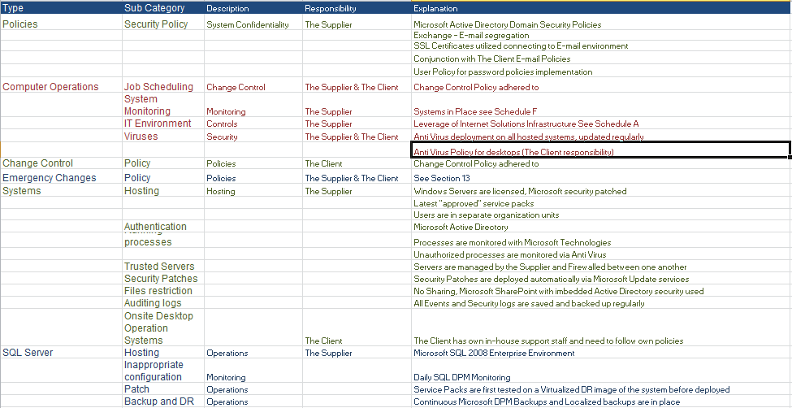

Disaster recovery

The Supplier will ensure that information and data under its responsibility is properly backed up on a daily basis and also that arrangements are made for recovery processes to be installed to minimise any potential disruption to the Client’s business. The Supplier is required to ensure that proper measures are in place to enable continuation of services in the event of unexpected disruptive events. These measures should include implementation and pre-testing of formal disaster recovery and business continuity planning within the Supplier’s business.

Veeam – (For the Modern Datacentre)
More info on (www.veeam.com)

The Supplier has partnership agreements with Veeam for backup and Replication Technologies
The Partner is fully licensed and possess the required skills to implement, operate and utilize the Veeam technology platform to enable its DR and Backup infrastructure strategies and networks

More than 100,000 companies worldwide including 94% of the Fortune Global 500 list use Veeam to protect their investments in virtualization. Their stories of success show how Veeam enables the Always-On Business with solutions for data centre availability.
Veeam® Backup & Replication™ provides reliable backup and replication for Hyper-V environments of any size. It also offers many fast and flexible restore options, including recovery of entire Hyper-V virtual machines (VMs) or individual files and application items.
- 2-in-1: backup and replication
- Multiple recovery options New
- Automatic verification of recoverability for every backup
- Built-in deduplication and compression
- Veeam Cloud Connect New
- End-to-end encryption

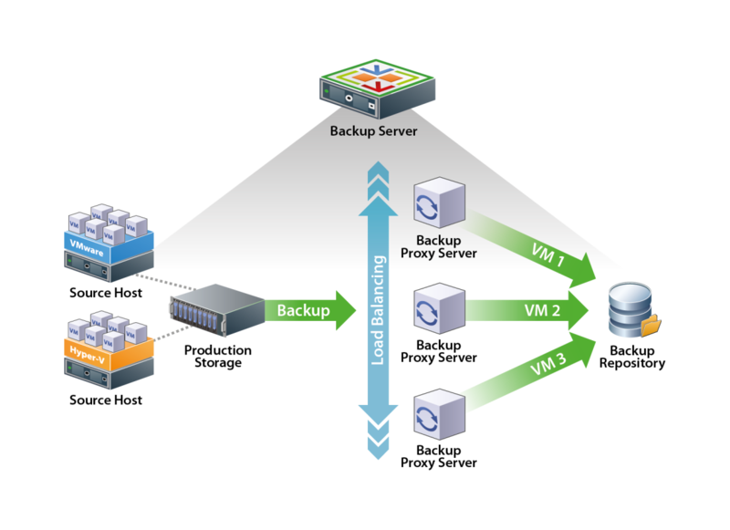

Encryption

Where requested and authorised by the Client, the Supplier agrees to utilise Secure Socket Layer (SSL) and/or IPSEC encryption technology in the electronic transmission of data to protect Client information from access by unauthorized users.

INTELLECTUAL PROPERTY RIGHTS AND

CONFIDENTIAL INFORMATION

Intellectual property rights

Both parties acknowledge the intellectual property rights of the other party whether registered or not.

- Subject to the provisions of this clause, unless otherwise agreed, the Parties and their respective suppliers shall retain all existing and future Intellectual Property Rights in their data, information, Software and Hardware, tools and other materials including any future enhancements, improvements and modifications thereof; whether stored on disk, tape, installed on any system or otherwise and whether or not the same is at any time placed in the possession or control of the other Party.
- During this Agreement, the Client shall, to the extent that it is legally entitled to do so, provide the Supplier with the non-exclusive rights to use or modify any Software, data and information or any other rights required for the purposes of providing the Services, subject to the specific terms and conditions provided to the Supplier regarding such utilisation.
- Subject to the provisions of any applicable licensing agreement, any work created or invention identified or any other Intellectual Property Rights developed at the Client’s specific instance and request (in writing) in the course of and for the provision of the Services by the Supplier or any Sub-Contractor of the Supplier that is fully funded by the Client shall be the property of and for the exclusive benefit of the Client. The Supplier shall deliver, or procure delivery from its representatives, of same and the necessary assignments of copyright or other Intellectual Property Rights.

Confidentiality

Both Parties agree to keep confidential all information concerning the other party’s business or its ideas, products, customers or services or trade secrets that could be considered to be “confidential information”. and not to utilise directly or indirectly same or to divulge or disclose it to any third party “Confidential information” is any information belonging to or in the possession or control of a party that is of a confidential, proprietary or trade secret nature and that is furnished or disclosed to the other party.

- All internal computer programming belonging to either Party, financial or other business details of either Party’s relationship with its clients;
- Details of either Party’s financial structure and operating results;
- The strategies and business policies of either Party
- All other matters of whatsoever nature which relate only to the business of either Party
- All management meeting reports, customer details, customer lists and other general advice and information which is peculiar to either Party’s business.
Confidential information will remain the property of the disclosing party and the receiving party will not acquire any rights to that confidential information.

Court orders

If the receiving party receives a Court Order to divulge any confidential information belonging to the disclosing party, then the receiving party is permitted to release such information to the court in accordance with any Court Order so served.

Destruction of data and records or return on termination

Upon termination of this Agreement, the receiving party, at the option of the disclosing party, will return all confidential information belonging to the other party.

System Confidentiality – Shared Environment

The Supplier warrants that all Client information, hosted on a shared virtualized infrastructure are protected due to the following configurations

- Authorized Sautech staff have login information
- Microsoft Active Directory configuration with different organizational units
- Virtual Domains and Virtual Lan of Subnetted Networks
- SQL Server are setup with the core Microsoft technologies and guidelines
- All DMZ’s and Network are configured and supported by our 3 Tier Network and Internet Security
- No external access to SQL server, only application layer access

Dispute resolution

Informal

If the Parties are unable to resolve any dispute resulting from this Agreement by means of joint co-operation or discussion between the individuals directly involved with the execution of this Agreement, within 7 (seven) days after a dispute arises or such extended time period as the Parties may in writing allow, then such a dispute shall be submitted to the most senior executives of the Parties who shall endeavour to resolve this dispute within 5 (five) days after it has been referred to them in writing;

Should the dispute not be resolved in the aforesaid manner, then it shall be resolved by way of arbitration in accordance with the provisions of below.

Arbitration

If the Parties agree to refer the dispute to arbitration, each Party:

Agrees that the Arbitration will be held at a mutually agreed venue in accordance with the then current rules of AFSA (“the Rules”) by 1 (one) arbitrator appointed by agreement between the Parties. If the Parties cannot agree on the arbitrator within a period of 10 (ten) Business Days after the date on which the Parties agreed in writing to refer the dispute to arbitration the arbitrator shall be appointed by the Secretariat of AFSA;

Expressly consents to any arbitration in terms hereof being conducted as a matter of urgency; and

Irrevocably authorises the other Party to apply, on behalf of the Parties, in writing, to the Secretariat of AFSA, in terms of article 23(1) of the Rules, for the arbitration to be conducted on an urgent basis.

Subject to clause below, the decision or award resulting from the arbitration shall be final and binding on the Parties, and may be made an order of court at the instance of either Party to the dispute. The Parties hereby irrevocably submit to the jurisdiction of the South Gauteng High Court of the Republic of South Africa (Johannesburg) should either Party wish to make the arbitrator's award an order of court.

There shall be a right of appeal as provided for in article 22 of the Rules.

The arbitrator will be held in camera, in the English language and will be kept confidential by the Parties.

The provisions of this clause shall not preclude any Party from access to an appropriate court of law for interim relief in the form of an interdict, mandamus or order for specific performance pending the outcome of the mediation or arbitration in terms of this clause or in respect of such mediation or arbitration, for which purpose the Parties irrevocably submit to the jurisdiction of the South Gauteng High Court of the Republic of South Africa (Johannesburg).

Limitation of liability

The Supplier is not responsible for any damages caused by the failure of the Client or its Affiliates or other suppliers to perform their responsibilities.

Neither Party shall be liable to the other Party, whether in terms of any indemnity or otherwise, for any loss or damage that such other Party may suffer, to the extent that such loss or damage arises in whole or in part from any act or omission of the other Party or its affiliates.

Notwithstanding any provision to the contrary in this Agreement, the aggregate liability of the Supplier to the Client in respect of all claims for damages, causes of actions and occurrences arsing under this Agreement, or any of the Service Schedule forming part hereof, arising during each contract year shall be limited to 12 (twelve) months Fees as set out under this Agreement.

Neither Party shall be liable to the other for a) any special or indirect damages whether within the contemplation of the Parties or not and / or b) loss of income or profit, howsoever arising, unless such losses or damages are the direct result of a Party’s gross negligence or wilful misconduct.

The Parties shall keep each other fully and effectively indemnified against injury to or death due to the negligent or wilful acts or omissions by such Party or its employees or agents acting in the course of their employment pursuant to this Agreement.

The provisions of clauses to inclusive are also stipulated for the benefit of the employees, agents and/or contractors of the Supplier.

The limitation of liability included in this section will survive this Agreement.

Duration &termination

The Initial Hosting Agreement is on a month to month basis

Payment on termination

In the event of termination of this Agreement for any cause, the Supplier will continue to be paid up to the effective date of termination for any fees or expenses due for services delivered up to that date.

Consequences of Termination

Upon termination of this Agreement, the Supplier (including its employees, representatives, subcontractors and agents) will cease work immediately and shall forthwith deliver up to the Client in hard copy or in electronic form, all Client data, deliverables, output, work in progress and other products of the Services whether finished or unfinished, together with any other documents, information and working papers relating to the Services in order that the Client can provide full continuity of the Services or arrange for a third party service provider to provide full continuity of the Services from the date of termination;

general

Relationship

- For the avoidance of doubt, the parties record and agree that pursuant to the implementation of this agreement the Supplier shall at all times act as an independent contractor;

- Nothing in this agreement shall constitutes an employer / employee relationship or an agency or a partnership in any shape or form between the parties nor authorise either of the parties to incur any liability on behalf of the other of them, save to the extent expressly provided for herein

Notices

Notices required under this Agreement are to be sent to the address and persons specified in Schedule L to this Agreement. Notices are to be sent in writing by registered post, recorded post, express courier service or be delivered personally.

Either Party may from time to time, by written notice to the other(s), vary its domicilium address to any other address within the Republic of South Africa which is not a post office box or poste restante.

All notices given in terms of this Agreement shall be in writing and any notice given by either Party to another ("the addressee") which:

is delivered by hand in a correctly addressed envelope to a responsible person during ordinary business hours at its chosen physical address or transmitted by telefacsimile by printout of a successful transmission, shall be deemed to have been received by the addressee on the first business day after the date of delivery or transmission, as the case may be;

is posted by pre-paid registered post form an address within the Republic of South Africa to the addressee at its domicilium address for the time being shall be deemed to have been received by the addressee on the tenth business day after the date of such posting;

sent by fax to a party at the telefax numbers specified above, shall be deemed to have been received, unless the contrary is proved, within 4 (four) hours of transmission if it is transmitted during normal business hours of the receiving party or within 12 (twelve) hours of the first business day of the receiving party after it is transmitted, if it is transmitted outside those business hours.

Is delivered by email shall be deemed to have been received by the addressee only once the email has entered the information system of the recipient. A delivery receipt it obtained

Standard of care

Each party will act in good faith in the performance of its respective duties and responsibilities and will not unreasonably delay or withhold the giving of consent or approval required for the other party under this Agreement. Each party will provide an acceptable standard of care in its dealings with the other party and its employees.

Assignment

Neither party may assign or otherwise transfer this Agreement without the prior written consent of the other party. In the event that consent for assignment is given, the terms of this Agreement will be binding upon each party’s respective successor.

Entire Agreement

This document constitutes the entire agreement between the parties and supersedes all other prior agreements being written or verbal between the parties for the provision of such services.

Severability

The provisions of this Agreement shall be deemed severable, and the unenforceability of any one of the provisions shall not affect the enforceability of other provisions. In the event that a provision is found to be unenforceable, the parties shall substitute that provision with an enforceable provision that preserves the original intent and position of the parties.

Changes to the Agreement

All changes to this Agreement must be approved in writing by authorised officials of both parties and follow the formal change control procedure set out in Schedule M to this Agreement.

Non-solicitation

During the term of this Agreement and for two years after its expiration or termination, neither party will solicit any employee of the other party for the purposes of offering employment.

Exhibits

The Schedules referred to in, and attached to, this document are to be considered an integral part of this Agreement.

Governing Law

The laws pertaining in the jurisdiction of South Africa where the Supplier’s principal office is located will govern this Agreement.

signatures

The following authorised representatives of each party execute this Agreement at the Commencement Date:

For the Supplier

Signature:

Name :

Position:

Date of Signing ……………………………..

For the Client

Signature:

Name :

Position:

Client :

Date of Signing ……………………………..

Place of Signature …………………………………………………………………………………..

Schedules

SCHEDULE A – STANDARD SERVICES

Server Management

Server Support
The Supplier will maintain the servers to this agreement (which may change from time to time) with the following services

- Monthly Scheduled Microsoft Windows Updates
- Daily Anti Virus Monitoring and automatic updates (by way of email notifications to Supplier)
- Microsoft Avtive Directory Support, Policy implementation and user login support services
- Capacity and resource planning / management (by way of Site24/7 Monitoring) The Client will also be setup to receive all notifications regarding
  - Resource Usage
  - Server resources Spiking
  - Server Uptime and Availability
  - Disk Usage

Kaspersky Server Anti Virus (Latest edition)

Cisco Switch Support
The Supplier will maintain the Switches to this agreement (which may change from time to time) with the following services

- Monthly Scheduled OS Updates (when needed)
- Network Card and Switch teaming (Failover Support
- Port Monitoring
- Switch Monitoring with Uptime Monitor (uptime notifictions)

Fortigate Firewall
The Supplier will maintain the 2 Firewalls in (JHB South African and Netherlands Remotely) to this agreement (which may change from time to time) with the following services

- Monthly Scheduled OS Updates (when needed)
- IPs Updates when needed
- Security and Rulebase management and cleanup
- IPSEC tunnel between the two devices
- Firewall Moniitoring with Uptime Monitor (uptime notifictions)

Synology NAS
The Client will rent a 1U Synology backup Server with 20TB Space that will be placed onsite for daily backup and disaster recover and will be hosted in the same rack as the servers

- All Servers will be File Level backed up daily using Synology backup software
- All Servers will be created as a disk image monthly as a VHD file extension
- The image will be kept 2 copies per month
- File Level backup will be kept 30days
- A Backup document will be submitted to be completed by die Client to specify what data to be backed-up

Backup Strategy
- System backups consists of the actual hard drive data. The purpose of System backups is to allow a full system rebuild through a System restore process. A partial data restore should be possible from a System backup set
- Data backups are full (not incremental nor differential) backups of the data.
- Daily Backups utilizes a combination of Microsoft DPM and Veeam Technologies or other technologies that are appropriate.

Backup Type | Description | Retention Policy
Daily | Daily Data backups will be scheduled to run 1 (one) minute after midnight | 30 Days
Monthly | Monthly System backups will be scheduled to run 1 (one) minute after midday on the last Saturday of the month. | 12 Full Sets per Annum
Annual | Annual backups will be scheduled to run 1 (one) minute after midday on the last Saturday of the Year. | 5 Sets

Veeam Technologies
Auto Failover Testing
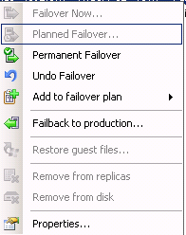

SCHEDULE C – SERVICE AVAILABILITY

Support

Schedule C provides a detailed list of the times and periods when the Standard and Non-standard Services will be available to the Client under the terms of this Agreement.

The Supplier’s standard business days and hours are pre-defined – Monday – Friday from 08:00 – 17:00
An After Hour Helpdesk System is available with 2 hours response time
Any request for services defined in Schedule A and B will be guaranteed under this timeline.

Should the hosting centre services be unavailable and not fall within the Supplier’s standard business hours, emergency support numbers will be provided to the Client that will not be invoiced separately from this agreement. This will only be applicable if the effected services affect the entire business and not a single employee or representative of the Client. Hosting Centre Support hours are 24/7/365 Backed by HETZNER, IS and Afrihost

.

SCHEDULE D – PLACE OF DELIVERY

Schedule D provides the location or locations where the Standard and Non-standard Services will be delivered to the Client under the terms of this Agreement.

The Client

MTN Gallo Manor (Afrihost)

The Supplier

Hosting Centre - Primary

Internet Solutions – A Division of Dimension Data
The Campus, 57 Sloane Street
Bryanston
Johannesburg
South Africa
Private Bag X163
Bryanston 2021

Hosting Centre - Backup

Hetzner Data Park
SamRand
Johannesburg
South Africa
Private Bag X163

Physical Address

34 and 36 Stokroos Avenue
Breaunanda
Krugersdorp
1739

Tel.: +27 11 768 1790
Tel.: +27 11 768 1035
Fax.: 086 650 3480
email support@sautech.net

SCHEDULE E – CHANGE CONTROL PROCEDURES

Schedule E provides information on the change control procedures to be followed when it is necessary to consider changes to Standard or Non-standard Services

This is a formal process used to ensure that changes to the Services are introduced in a controlled and coordinated manner. It reduces the possibility that unnecessary changes will be introduced without forethought, introducing faults into the Services or undoing changes made by other users of software.
The goals this change control procedure includes;

- minimal disruption to services
- reduction in back-out activities
- cost-effective utilization of resources
- change implementation

The Client will send the Supplier an Authorization Organogram which will specify the following information

- Change Control Officer
- Procurement Officer
- Authorized signatories

Operational Changes
The Client will utilize the following methods to request a change control or system update from the Supplier. The below table will illustrate the change control flow;

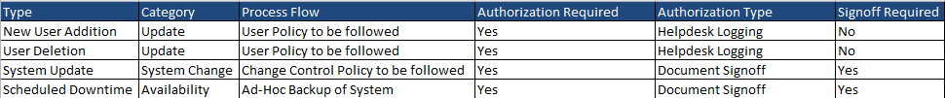

Emergency System changes
Should one of the following conditions apply, it will be considered to be an emergency system change

- Virus Outbreak
- Microsoft Security patch deployments
- Hardware failure
- Internet failure
- Any other unforeseen circumstance

In the event of the above, The Client will be notified of the emergency and the Supplier will perform emergency maintenance on the affected server of services within 1 hour of being notified of the occurrence.

The Emergency will be logged and tracked via The Supplier Helpdesk system
Should new hardware or patches be deployed, the hardware or software will be tested first on a DR image backup of the environment first before applying the service or hardware change to the environment.

Any Scheduled Service pack deployments being emergency or not, will be tested in a DMZ zone deployment of the infrastructure before applying the nominated update to the life environment on a scheduled basis.

All Changes that does not affect the environment will be signed off by the nominated IT Manager and representatives of both parties before such action implemented.

SCHEDULE F – SERVICE MONITORING AND PERFORMANCE MEASUREMENT

Schedule F provides detailed information on the monitoring of Standard and Non-standard Services delivered to the Client and the metrics and other means to be applied to each Service component to measure the performance of the Services delivered under the terms of this Agreement.

USER REQUESTS

The following tools are utilized by the Supplier to monitor support and system management

The Supplier utilizes Adventnet System Centre to log requests, perform backup checks and scheduled maintenance. This tool enables the Supplier to manage and update requests, adhere to the Service Level Agreement, print reports and update service requests.

The Client is also created on the system to pull its own reports, monitor progress and update requests.

Issues pertaining only to the business of the Client will also be logged via the Supplier Helpdesk System

HOSTING CENTRE MONITORING

The Supplier uses Microsoft System Centre to perform monitoring on the hosting systems
The following table illustrated the technology and mechanisms used to perform the monitoring functions;

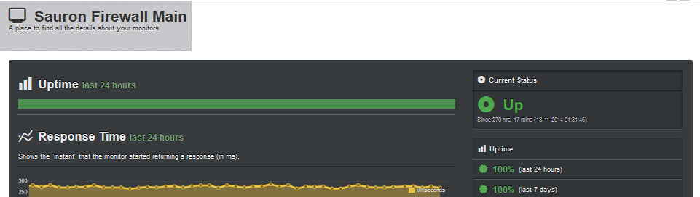

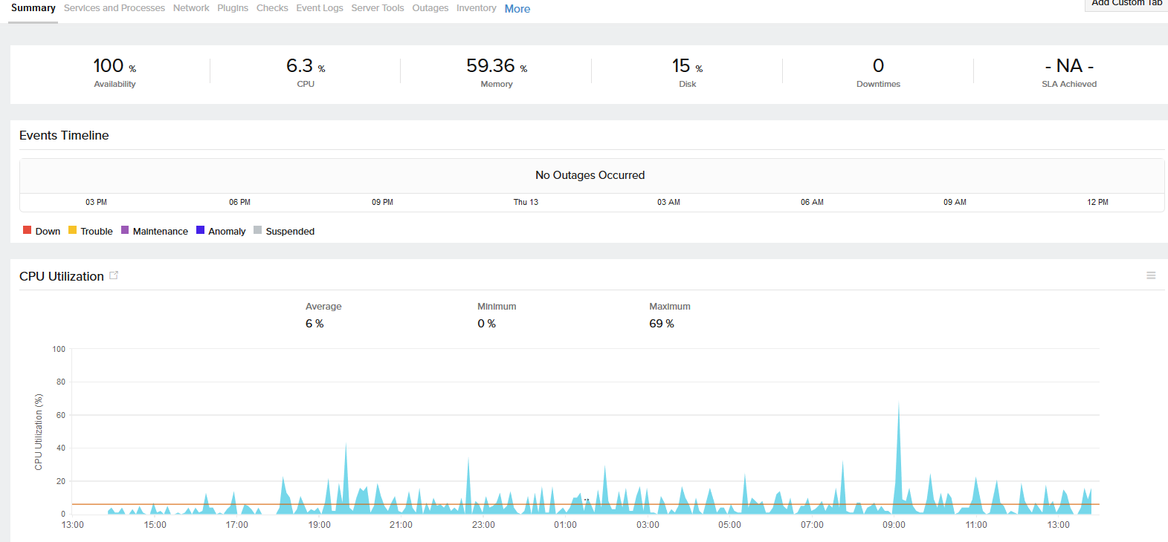

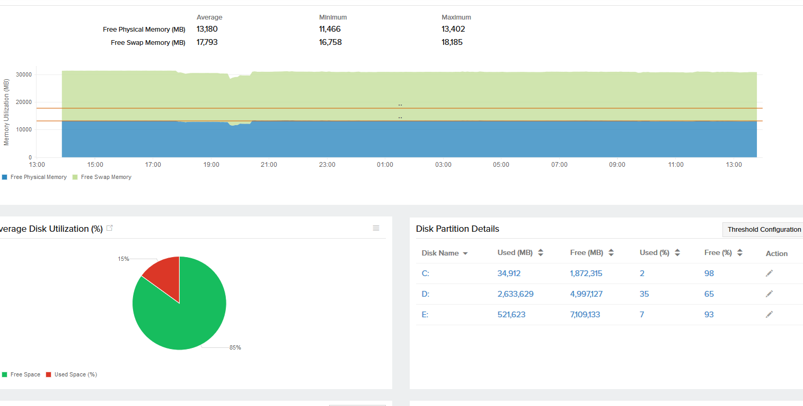

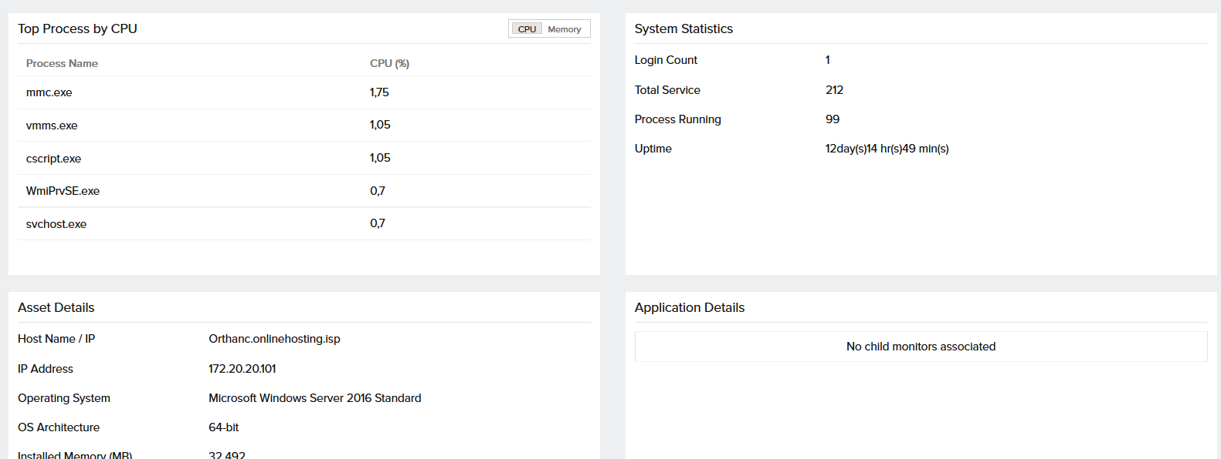

SCHEDULE G – SERVICE LEVEL REPORTING

Schedule G provides information on the Service level reports required under the terms of this Agreement.

The Service Level Reporting will be downloaded and monitored through the Supplier Service Centre System.
The location for the Service Level Reporting tool is: http://helpdesk.sautech.co.za

From the system, a full report can be viewed detailing the following;

- Requests or services outside of SLA hours
- Requests or services that did not meet the SLA terms
- Requests or services that did meet the SLA terms
- Requests or services that were escalated
- Requests or services that were escalated and the resolution to the request

Note: ERT shall mean (Estimated Repair Time)

Problem Priority | Status | Impact | Time | Type | ERT
Priority 1 | Mission critical | Serious financial impact | 1 Hour Response | No Connectivity affecting more than 1 user | 2 Hours
Priority 2 | Extremely urgent | Significant financial impact | 3 Hour Response | No Connectivity affecting 1 User | 4 Hours
Priority 3 | Urgent | Medium financial impact | 5 Hour Response | User Removal or Creation | 8 Hours
Priority 4 | Medium priority | Minimal financial impact | 1 Business Day | Quotation | 24 Hours
Priority 5 | Low Priority | No financial impact | 2 Business Days | Hardware / Software Delivery, General Queries | 48 Hours

SCHEDULE H – SUPPORT & SERVICE DESK SERVICES

Schedule H provides information on the Service desk services and on the On-site and Off-site Support services available to the Client under the terms of this Agreement.

Problem Definition

The following standard problem definitions will apply to the services provided under the terms of this Agreement.

Problem Priority | Status | Impact
Priority 1 | Mission critical | Serious financial impact
Priority 2 | Extremely urgent | Significant financial impact
Priority 3 | Urgent | Medium financial impact
Priority 4 | Medium priority | Minimal financial impact
Priority 5 | Low Priority | No financial impact

Problem Escalation

To ensure that the Client receives senior management attention on unresolved issues, the Supplier operates a problem escalation procedure in order that any unresolved problems are notified to the Suppliers operational and management personnel on a priority basis dependent upon the severity of the problem. There are five levels of Problem Priorities and three levels of escalation. This escalation process is specified in Schedule I to this Agreement.

SCHEDULE J – FEES AND EXPENSES

Schedule J provides information on the fee structure and reimbursable expenses to be charges by the Supplier in respect of Standard and Non-standard Services deliverable under the terms of this Agreement.

Type | Description | Qty | Unit Price | Total
Support | Physical Windows Server Support | 6 | R695.00 | R4 170.00
Monitoring | Site 24 Monitoring | 6 | R55.00 | R330.00
Support | Cisco Switch Support | 2 | R250.00 | R500.00
Monitoring | Uptime Monitoring | 2 | R55.00 | R110.00
Support | Fortigate Firewall Support | 2 | R1 600.00 | R3 200.00
Monitoring | Site 24 Monitoring | 2 | R55.00 | R110.00
Rental | Synology 1U 20TB | 1 | R2 000.00 | R2 000.00
Backups | 30 Days Rentention | 6 | R195.00 | R1 170.00
Software | Kaspersky Server Anti Virus | 6 | R49.00 | R294.00

Schedule K provides information on any Penalties and Refunds payable in respect of defective service levels on Standard and Non-standard Services deliverable under the terms of this Agreement.

Under this SLA, should the following conditions in the below table be affected, the table will illustrate the penalties by The Supplier

This SLA is based on Sautech services and not services supplied by Afrihost

Problem | Duration | Penalty
Server uptime not adhered to | Less than 97% uptime | 1 Month Credit
Server uptime not adhered to | Less than 95% uptime | 2 Month Credit
SLA Escalation not adhered to | More than 3 times | 1 Month Credit
SLA Escalation not adhered to | More than 5 Times | 2 Month Credit
SLA Escalation not adhered to | More than 8 Times | Agreement Termination

SCHEDULE L – NOTICES

Schedule L provides address information and contact details for the serving of formal notices in writing to either the Supplier or the Client under the terms of this Agreement.

The Client

Physical Address

ANVIL MINING CONGO SA
2622, Avenue USOKE
Commune de Kampemba
Lubumbashi – DR Congo

The Supplier

Physical Address

Mr Riaan van Jaarsveld
Chief Executive Officer
rvjaarsveld@sautech.net
34 and 36 Stokroos Avenue
Breaunanda
Krugersdorp
1739

Tel.: +27 11 768 1790
Tel.: +27 11 768 1035
Cell: +83 481 9449
Fax.: 086 650 3480

SCHEDULE M – CHANGES TO AGREEMENT

Schedule M provides information on the change control procedures to be followed for when it is necessary to consider changes this Agreement.

CONTRACT CHANGE MANAGEMENT PROCEDURE

Scope
Changes will be made by written agreement between the Client and the Supplier in accordance with the terms of this Schedule.

Procedure

To initiate a Contract Change, the following procedure shall be adopted:
    - The requestor prepares a request in collaboration with the other party, which shall contain or have attached all information necessary to enable the recipient of the request to consider the request and reach an informed conclusion, but at least the following information;
      - a description of the requested Contract Change;
      - the reason for the Contract Change;
      - suggested new or amended wording to the Agreement or the Service Orders in question;
      - suggested plan for the implementation of the Contract Change, if applicable;
      - implementation roles and responsibilities;
      - cost implications;
      - Impact analysis.
    - The requestor will submit the request to the appropriate authorised person at the other party as may be determined from time to time.
    - The recipient of the request shall within a reasonable time review the request. If necessary, the request will be debated and/or negotiated at a meeting scheduled between the parties for purposes of the request.
    - If the Contract Change is not accepted, it shall be confirmed in writing to the other party.
    - If the initial persons from the respective parties are unable to agree on a proposed Contract Change, the matter may be escalated to the parties’ respective executives.
    - If the Contract Change is rejected, the receiving Party shall provide to the requesting Party in writing, within 5 (five) Business Days, the reasons for rejecting the requested Contract Change request, whereupon the requesting Party may submit a revised Contract Change request which takes into account the receiving Party's reasons for rejecting the initial Contract Change request.

No change to this agreement will be honoured unless reduced to writing and signed by all parties to this agreement.

